FOR IMMEDIATE RELEASE

KH Roberts partners Leistritz to advance plant-based food innovations in Southeast Asia

Singapore, April 2021 - KH Roberts, a leading creator and provider of aromas and tastes, and Leistritz, a renowned leader in extrusion innovation for pharmaceutical and food processing, have come together in an innovation partnership to advance the research and development of plant-based foods specifically for Asian consumer needs. The partnership amalgamates leading expertise and deep knowledge from both companies and offers support to their growing customer base in the region.

“We bring together KH Roberts’s expertise in aromas and tastes with Leistritz’s expertise in process engineering in this second pilot scale extruder located in KH Roberts. We have been operating the first pilot scale extruder jointly with a local Singapore university since October 2020 for academic research and educational training on plant-based foods. Innovating future foods and tastes is at the heart of what we do and we recognize the value of open collaboration with fellow industry leaders and promising food start-ups to achieve this. Through our new partnership with Leistritz, KH Roberts is able to further expand and develop its flavour and masking solutions in plant-based foods”, said Dr. Peter K.C. Ong, Chief Executive Officer,
KH Roberts.

As part of KH Roberts’s industry-academic collaborations, Singapore’s first operational pilot scale twin screw extruder for plant-based foods was commissioned in September 2020. The extruder is key to producing new innovative alternative protein foods with authentic meat-like textures to meet the latest consumer demands. Fully supported by KH Roberts’s expertise in aromas and tastes, the first pilot scale extruder has been instrumental in advancing academic research and teaching purposes with the objective of equipping future food technologists with the knowledge and skill sets of plant-based food technology.

Leistritz Singapore’s General Manager Extrusion, Alf Hofstetter, said “Leistritz stands for technologically sophisticated products and a high level of innovation. These two pilot scale extruders are amongst the first to be commissioned and operational in Singapore and Southeast Asia, showcasing our strong expertise in this technology. This joint development with KH Roberts allows us to further enhance our food processing and engineering expertise outside of Europe, and jointly support the fast-developing alternative protein markets in Southeast Asia.”

The KH Roberts-Leistritz collaboration highlights a mutual recognition of the growing importance of flavours and advanced food processing in the emerging plant-based foods market. The collaboration will enable KH Roberts to strengthen its position at the forefront of taste innovation, and develop open collaboration opportunities with leading global food innovators and promising start-ups.

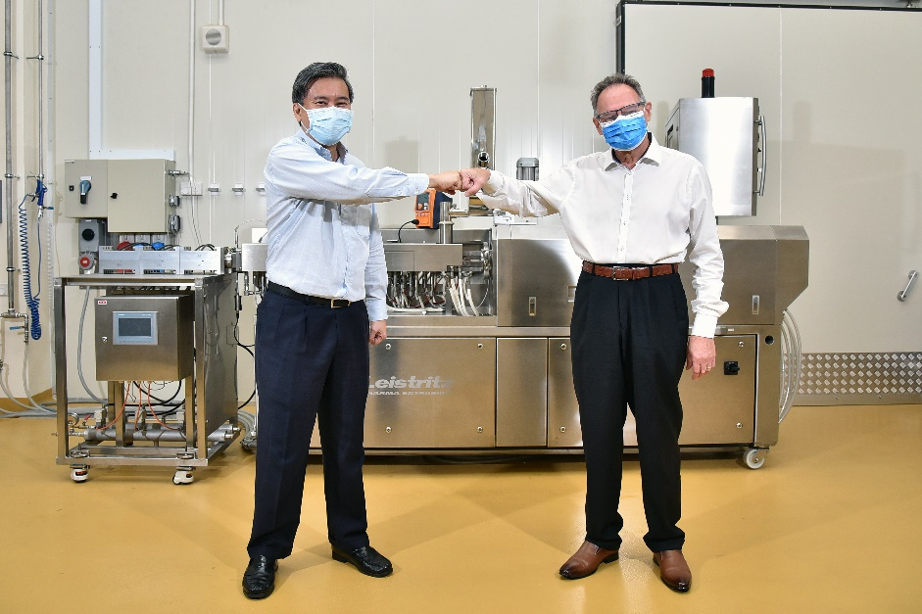

Here’s a corona-compliant handshake to the partnership – Dr. Peter K.C. Ong, Chief Executive Officer at KH Roberts (l.) and Alf Hofstetter, Managing Director Extrusion at Leistritz SEA

About KH Roberts
At KH Roberts, we craft future flavours that bring delight and imagination to the world. As one of Asia’s leading creators of aromas and tastes, we are constantly pushing the boundaries, always discovering, always innovating. With world-class research, innovation, and manufacturing capabilities, supported by a keen understanding of Asia’s diverse cultures, tastes and preferences, we bring to our customers crafted flavours that are novel, relevant, and delightful. For more than 50 years, KH Roberts, headquartered in Singapore, has established an extensive network of clients and partners from around the world. They range from private labels to multinational consumer companies, serving diverse segments from Foods & Beverages, Health & Wellness to Pharmaceuticals.

About Leistritz
For more than 80 years, Leistritz Extrusionstechnik GmbH, headquartered in Nuremberg, Germany has been manufacturing twin screws for compounding technology. Leistritz customers benefit from the know-how in various areas of material processing for the Plastic industry, as well as life science and pharmaceutical applications. The company employs about 240 people worldwide with three branch offices: in the US, in China, and since 25 years ago in Singapore (Leistritz SEA Pte Ltd).

Media contact

Maru Miranda
Marketing Specialist, Brand and Communications, KH Roberts
E: maru.miranda@kh-roberts.com

Marija Perisic
Public relations manager, Leistritz Extrusionstechnik GmbH
E: mperisic@leistritz.com

