PRESS RELEASE 2/2021

ARGUS Additive Plastics relies on a Leistritz ZSE 40 iMAXX extruder

With the ZSE iMAXX series, Leistritz Extrusion Technology offers twin-screw extruders that are perfect for use in masterbatch production.

Nuremberg (March 2021) – Since January, ARGUS Additive Plastics has a new ZSE 40 iMAXX
twin-screw extruder from Leistritz in operation. "At short notice, we were looking for a system to use in our technical center in order to further develop formulations, but on which we could also produce smaller quantities," explains Wilfried Helle, plant manager at ARGUS. "Leistritz responded quickly and offered us an ideal solution." The company, based in Büren/Germany, produces about 30,000 t of additive masterbatch annually for applications such as film, pipe, sheet and artificial turf production, BOPP, injection molding, mono- and multi-filaments, tapes, nonwovens.

Compelling technology
Due to the high specific torque (up to 15.0 Nm/cm³) combined with an increased volume in the screw (OD/ID = 1.66), the ZSE iMAXX machines are among the world's most powerful co-rotating twin-screw extruders. "This results in high-quality homogenization with quite low energy input," confirms Leistritz Area Sales Manager Guido Kraschewski. Since ARGUS uses the ZSE 40 iMAXX for trials, the extruder must be able to handle product changeovers very efficiently. This plus a high product quality level is paramount in masterbatch production. "We were therefore looking for a convincing solution not only technologically, but also in terms of its flexibility," says Wilfried Helle.

Easy cleaning
Frequent product changes go along with increased cleaning effort. Particularly in this area, the
ZSE 40 iMAXX extruder is impressive, because it is designed with closed surfaces that are easy to clean. A stainless steel cover protects the entire processing and drive unit from contact or contamination. "Another positive aspect for ARGUS with this extruder was the small space it needs," explains Guido Kraschewski. "After all, the temperature control unit is fully integrated in the frame." A central water connection for the entire system is all one needs. Whether temperature control unit, cooling or heating elements, the clever positioning of the components ensures optimum accessibility behind the doors in the frame or on the process unit. Individual components are extremely easy to clean and replace.

Optimum additive equipment
Feeding additives is what makes masterbatch processing challenging: If additives with a low melting point are added, they might melt in the main feed and block it. The product quality would then no longer be ensured. ARGUS therefore uses the Leistritz LSB XX side feeder with cooled barrels and screws. The increased OD/ID ratio (2.0) results in an increased conveying volume as well as better venting for materials with very low bulk densities. Efficient venting is achieved by the axially displaced arrangement of the openings.

Devolatilization is a key part of the process. It removes volatile components from the melt. In this plant, a Leistritz side degassing system is used. The largest possible free volume in the screw flight of the extruder in combination with the continuous renewal of the product surface create optimum conditions during the degassing of the polymer melt. The two screws installed in the degassing unit, which rotate in the same direction, push any escaping melt back into the process chamber, but allow all gases to escape. This prevents blockages or deposits in the degassing barrel. This enhances productivity and safety of plant operations.

Image (©Leistritz):

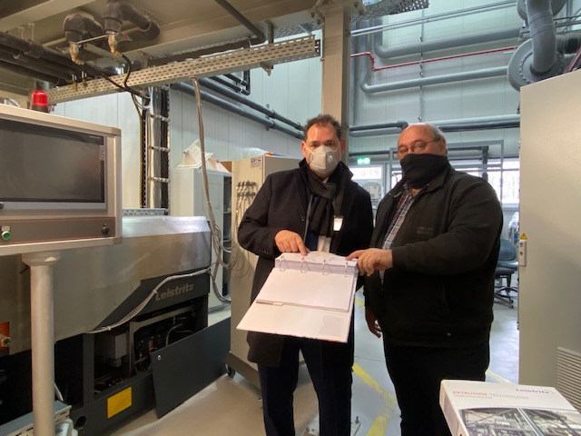
During commissioning under corona conditions: Guido Kraschewski from Leistritz and Wilfried Helle from ARGUS.

Leistritz Extrusion Technology
Extrusion solutions and systems provided by Leistritz Extrusion Technology are employed in plastics production, pharmaceuticals and life science, in recycling and food production, masterbatch, compounding and laboratory extrusion. Global engineering expertise and services are provided by a staff force of 240 working from headquarters in Nuremberg, Germany and locations in France, the USA, China and Singapore.

For more information:
Leistritz AG
Press and Public Relations
Marija Perisic
Markgrafenstr. 36-39
90459 Nuremberg
Phone: +49 (0) 911 4306 120

Email: mperisic@leistritz.com

