PRESS RELEASE 4/2021

Two become one – a ZSE MAXX extruder for LFT compounding

LFT-D plant with recycled plastics installed – New project in the long and successful cooperation of Dieffenbacher and Leistritz

Nuremberg (June 2021) – "Working together to find a solution is just as important as being part of the solution," says Frederik Huck, regional sales manager at Leistritz Extrusionstechnik GmbH. He describes a project at Dieffenbacher GmbH Maschinen- und Anlagenbau, where Leistritz's extrusion expertise was in demand. The Eppingen-based manufacturer of press systems and complete production plants is currently building a production line for manufacturing large-sized LFT-D (long fibre thermoplastic direct molding) components in large quantities in the USA, at present the best-performing line of its kind. Once finished, the line will be able to process up to 100% recycled plastic.

"An important component of this line is our ZSE MAXX twin-screw extruder, where the material is processed with glass fibres being added," says Frederik Huck. The ZSE MAXX series is ideal because the machines offer an optimal combination of high torque (up to 15 Nm/cm³) and large free volume in the screw (OD/ID of 1.66). This guarantees energy-efficient melt processing as well as gentle incorporation of the reinforcing fibres.

Process description
In an LFT-D process with 30-50% fibre content, two twin-screw extruders are used. After having fed the individual components gravimetrically, the melt is plasticised in the first machine. The melt is transferred to the fibre extruder via a special die in order to achieve the best possible incorporation and impregnation of the continuous glass fibre rovings. Here glass fibres can have a length of up to 25 mm. Due to the excellent impregnation, very little wear occurs in the processing section of the machine. In combination with Dieffenbacher's overall system concept, first-class material characteristics are obtained in the end product.

In the current project, the required fibre content of 10-20% was lower than for standard compounds. Therefore the process could be carried out with so-called single-machine technology. "Plasticizing of the matrix as well as incorporation of glass fibres is therefore performed with only one extruder," explains Frederik Huck. "The melt is discharged via a specially designed die to ensure the best possible subsequent processing in the LFT system and in the downstream pressing process." Several tests and adaptations were carried out in advance to optimize the extruder's performance data, the screw geometry and the melt discharge.

Successful cooperation
"Leistritz provided us with significant support in the execution of this project and made an important contribution to its success by working together with us on an equal footing," says Marco Hahn, Director Sales Forming Business Unit at Dieffenbacher. "Synergies like these are worth their weight in gold when it comes to developing new projects, and we hope to be able to implement further exciting solutions with Leistritz in the future."

Since 1999, the two companies have completed more than 40 successful joint projects. The lines are operated worldwide, predominantly for the automotive supplier industry. "The long-standing strong partnership with Dieffenbacher is truly outstanding, and we are all the more pleased to continuously develop the application areas and processes in a close and cooperative manner," says Frederik Huck.

Image (©Dieffenbacher):

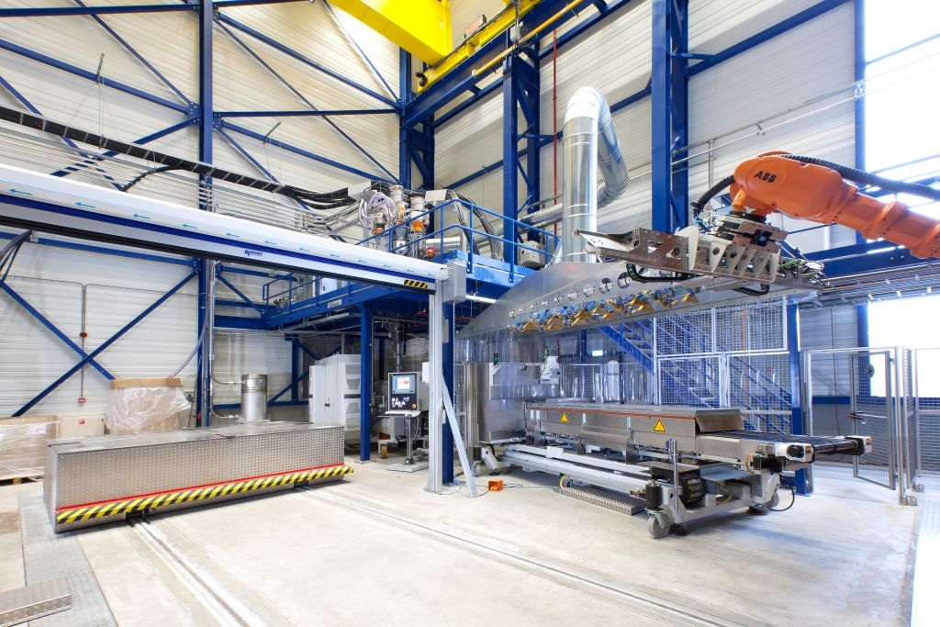

A look inside of the Dieffenbacher LFT-D system.

Leistritz Extrusionstechnik GmbH
Extrusion solutions and systems provided by Leistritz Extrusionstechnik GmbH are employed in plastics production, pharmaceuticals and life science, in recycling and food production, masterbatch, compounding and laboratory extrusion. Global engineering expertise and services are provided by a staff force of 240 working from headquarters in Nuremberg, Germany and locations in France, the USA, China and Singapore.

Press contact:
Leistritz AG Leistritz Extrusionstechnik GmbH
Press and Public Relations Head of Marketing & Communications
Marija Perisic Daniela Franz
Markgrafenstr. 36-39 Markgrafenstr. 36-39
90459 Nuremberg 90459 Nuremberg
Phone: +49 (0) 911 4306 120 Phone: +49 (0) 911 4306 9623

Email: mperisic@leistritz.com Email: dfranz@leistritz.com

